**NOTE: -** Concepts related to Transformer and LM-35 are not added but they can be asked so prepare it by yourself.

**EXPERIMENT 1**

**BRIDGE CIRCUIT**

It is a simple circuit consists of a network for four resistance arms forming a closed circuit, with dc source of current applied to two opposite junctions and a current detector.

It is used for measuring component values such as R, L, C.

It uses idea of null indication at the bridge balance → null detector.

**Types of Bridges**

**AC Bridge**

* Maxwell’s Bridge
* Hay’s Bridge
* Schering’s Bridge
* Wein’s Bridge
* Resonance Bridge

**DC Bridge**

* Wheatstone’s Bridge
* Kelvin Bridge
* Kelvin Double Bridge

|  |  |
| --- | --- |
| **DC Bridge** | **AC Bridge** |
| DC supply | AC supply |
| Contains resistance only | Contains Resistance, Inductor and capacitor |
| Phasor’s not involved | Phasor’s are involved |

**AC Bridge: -**

AC bridges are the circuits that are used for the measurement of electrical quantities such as inductance, capacitance, resistance.

**Balance condition: -**

The bridge is balanced when there is no current through the galvanometer, or when the potential difference at points C and D is equal, i.e. the potential across the galvanometer is zero.

**Unbalance condition: -**

When current flow in galvanometer.

**Theory:**

A bridge circuit is used to measure the value of unknown resistance, inductance and capacitance is known in the bridge. The AC bridges are very convenient and give the accurate result of the experiment. The bridge has four arms, one AC supply source and one balance detector. It works on the principle that the balance ratio of the impedance will give the balanced condition to the circuit which is determined by null detector.

|z1| |z4|=|z2| |z3|.

And phase condition: <θ1+ <θ4 = <θ2+ <θ3.

**EXPERIMENT 2**

**HALF WAVE RECTIFIER**

Half-wave rectifiers transform AC voltage to DC voltage. It is defined as a type of rectifier that allows only one-half cycle of an AC voltage waveform to pass while blocking the other half cycle.

**Filter**

The filter is a device that allows passing the dc component of the load and blocks the ac component of the rectifier output. Thus the output of the filter circuit will be a steady dc voltage.

**USES**

A half-wave rectifier is used in soldering iron types of circuit and is also used in mosquito repellent to drive the lead for the fumes.

**Ripple factor:**

Ripple factor is a measure of effectiveness of a rectifier circuit. It is defined as the ratio of RMS value of the AC component (ripple component) Irrms in the output waveform to the DC component VDC in the output waveform.

* **Ideal value of ripple factor is** **zero.** Zero ripple factor means a perfectly dc quantity.
* The ripple can be reduced by smoothing capacitors which converts the ripple voltage into a smoother dc voltage.

**Theoretical values: -**

**(without filter): -**

**Ripple factor = 1.21**

**Efficiency = 40.5%**

**(with filter):**

**Ripple factor = 0.577**

**Use of Capacitor**

Capacitors are used to smooth (filter) the pulsating DC output after rectification so that a nearly constant DC voltage is supplied to the load.

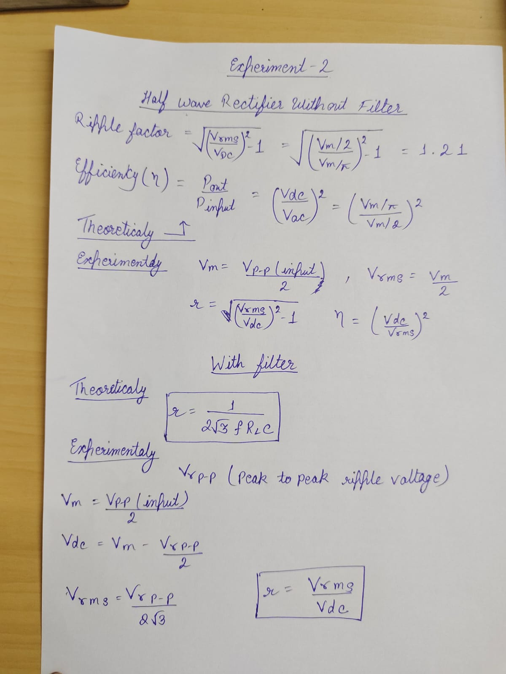

**EXPERIMENT 3**

**FULL WAVE RECTEFIER**

A full wave rectifier is defined as a rectifier that converts the complete cycle of alternating current into pulsating DC.

**USES**

Full Wave Bridge Rectifier is used to detect the amplitude of the modulating radio signal.

**Theoretical values: -**

**(without filter): -**

**Ripple factor = 0.48**

**Efficiency = 81%**

**(with filter):**

**Ripple factor = 0.288**

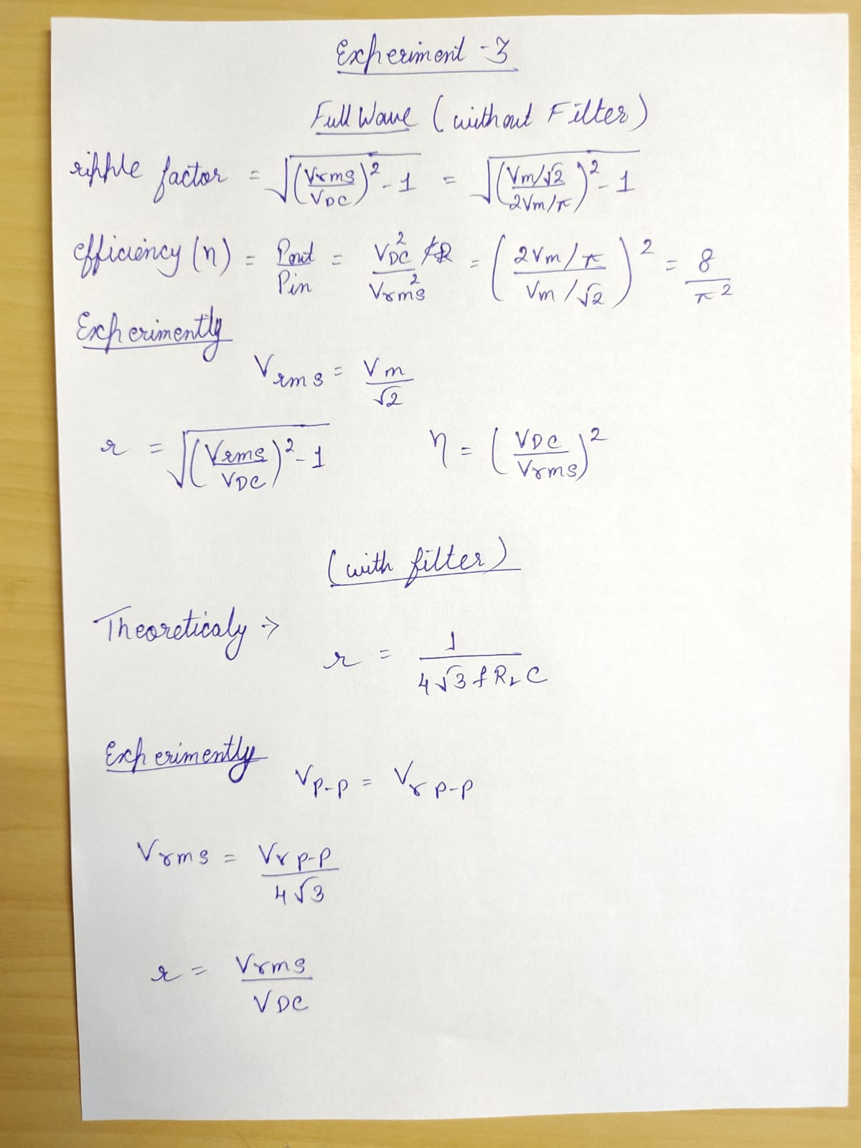

**EXPERIMENT 4**

**LM-35**

It is an electronic device which is design to measure hotness or coldness of an object.

It possesses low self-heating and does not cause more than 0.1C

**Remote Sensing**

Remote sensing is the process of detecting and monitoring the physical characteristics of an area by measuring its reflected and emitted radiation at a distance.

**Operating Range of LM-35** -55 C to 150 C

**Minimum voltage to LM35** = -2V

**Max Voltage to LM35** =35V

**Temp** = out voltage/ 10mV/C

* If we got 10mV at output than temperature increase 1 C

**In LM35 remote sensing application**

**If temp>28 C LED glows**

**Some other important terms**

**Oscilloscope:** **-**  An oscilloscope is a device that allows you to see how voltage changes over time by displaying a waveform of electronic signals.

**Spectrum analyzer: -** A spectrum / signal analyzer measures the magnitude of an input signal versus frequency within the full frequency range of the instrument.

**Harmonic distortion analyzer: -** A total harmonic distortion analyzer calculates the total harmonic content of a sinewave with some distortion, expressed as total harmonic distortion (THD).

**Pressure transducer: -** A pressure transducer, often called a pressure transmitter, is a transducer that converts pressure into an analog electrical signal.